EXPERIMENT – 7
Code Injection Using Ptrace in Kali Linux

Aim:
To demonstrate code injection on a running application process using the ptrace system call in Kali Linux for understanding low-level process manipulation and security vulnerabilities.

Procedure:
Step 1: Start Environment
Open Oracle VirtualBox and start Kali Linux virtual machine. Log in to the system.

Step 2: Create Target Program
Create a simple C program that runs continuously. This program will act as the target process for testing.

Step 3: Run Target Application
Execute the target program and identify its Process ID (PID), which is required to interact with the running process.

Step 4: Create Injector Program
Write a C program that uses the ptrace system call to attach to the target process and access its internal state such as registers or memory.

Step 5: Compile Programs
Compile both the target and injector programs using a C compiler so they can be executed.

Step 6: Attach to Target Process
Run the injector program and connect it to the target process using the PID. This allows control over the target process.

Step 7: Modify Execution
Change the target process behavior by altering its execution flow or memory content using ptrace.

Step 8: Observe Changes
Resume the process and observe how its behavior is modified due to the injection.
Output:
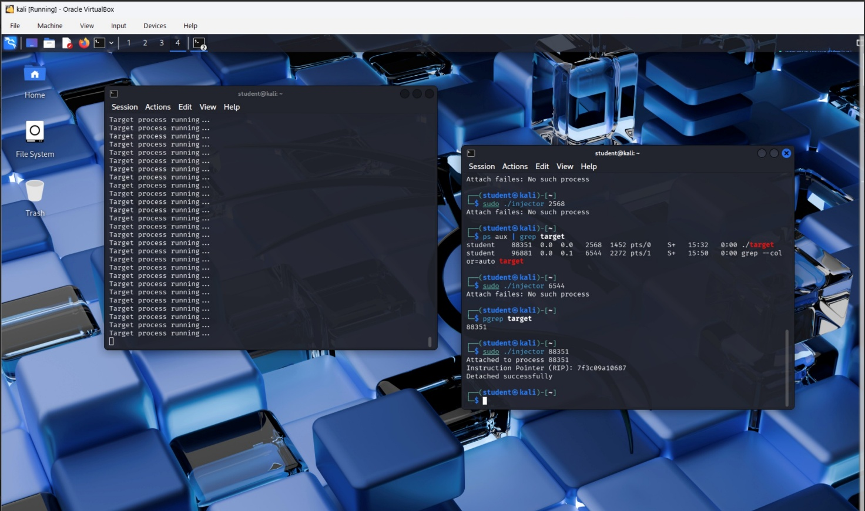

Result:
Code injection using ptrace was successfully demonstrated, showing how process execution can be controlled and highlighting the importance of system-level security and process isolation.

